**Open Configurable Networks Lab0**

**Todo: Identify a real-world radio frequency signal of your choosing and investigate it! You can choose any signal you wish, so long as its operating frequency is within the range of your SDR receiver. Feel free to consult with your instructor if you have doubts whether your preferred signal is appropriate for this exercise. Submit the following for your observation as a short report via blackboard:**

For the PLUTO device, the frequencies coverage is between 325Mhz to 3.8Ghz, according to the introduction of the lab, I would like to choose 2.45GHz ISM band for my experiments.

And the parameter of it as shown on the website.

1. **center frequency of the signal**

2.45Ghz.

1. **screen capture of the spectrum analyzer window showing the signal**

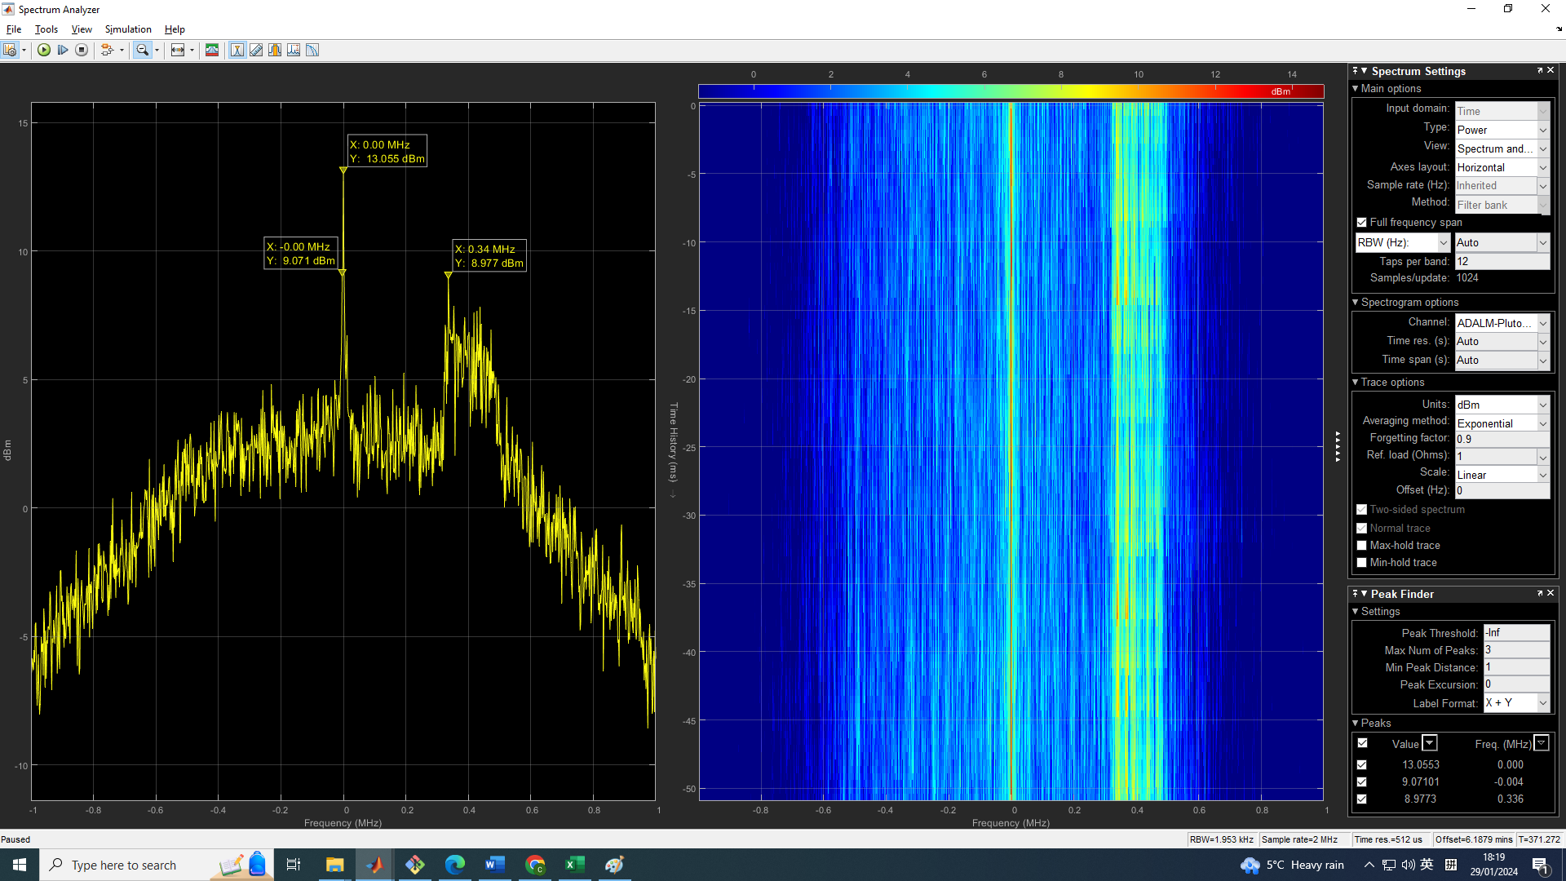

1. **estimate of the signal bandwidth**
2. **Describe any characteristics of the signal based on your research of the signal/ system or based on your observations of its spectrum. It is OK if you don’t fully understand the details at this stage.**
3. **Observations from sub-section 3.1.VI**
   1. **What happens to the spectrum plot when you adjust the Center frequency parameter?**
   2. **What happens when you adjust the Gain parameter?**
   3. **What happens when you adjust the Baseband sample rate parameter? Hint: Be sure the Full Frequency span box is checked in the Spectrum Settings panel of the Spectrum Analyzer.**